Quick Note: We’ll be using DBeaver, but if you just need to do a quick mockup, there are lots of free tools online like this: https://www.db-fiddle.com/
In the real world (and your project), you’ll probably have a Database connected to a Backend Application, and you’d be running each on separate servers. But you CAN have light databases that live in the Backend App (H2 in-memory database anyone?)

What is a Database?
- “A Database is an application that we use to store, view, and manipulate long term data.
  - (“long term data” includes anything that shouldn’t get wiped after the app stops running like user information, product prices, forum posts).

- The front end (web pages) and back end (Python APIs? Java APIs?) aren’t fit to store data long term. Databases are an integral part of the full stack!
  - Full Stack: Webpage (the client/front end) -> Middleware (the server/backend) -> database (storing long term data)

- Databases are basically necessary for any serious organization, and storing/accessing the large amounts of data that robust applications accumulate is a very desirable skill.
  - We’ll be using our database to communicate with our Python application by manipulating and viewing the data in the database.

SQL
- NOT a programming language. It’s a query language. SQL stands for “Structured Query Language”
  - (“ess q ell”, “sequel”, NOT “squill” or they’ll laugh at you)

- SQL is the query language we use to create and communicate with our databases by storing, viewing, and manipulating the data.
  - SQL is used exclusively with relational databases (read below)
  - SQL provides commands for our CRUD operations: Create, Read, Update, and Delete
    - A user of an application is typically able to create, read, update, and delete data off of the database.

- SQL has a readable, English-like syntax:
(Returns all of the user ids of users named Steve)

- SQL itself is not a database, it’s a language that we use to CREATE databases and manipulate their data.
  - Individual vendors implement the SQL standard (or most of it) and add in some custom features to convince people to use their version. Think of each vendor as a different implementation (or dialect, or flavor) of SQL.
    - MySQL
    - PostgreSQL
    - OracleSQL
    - MariaDB
    - Aurora
  - We’ll be using SQLite, because it’s the only one that FNMA didn’t give us headaches with.

In modern times, we’re seeing a push away from SQL toward NoSQL due to the rise of Big Data datasets. (Most big companies definitely still use both.)

Relational Database Management Systems (RDBMS)
- All of the SQL dialects we can choose from are considered Relational Database Management System (RDBMS). In other words, they’re tools that help us create and manage relational databases
  - SQL databases are based on the relationships between the tables in the database. Hence “relational”.

- Since SQL is focused on building and maintaining the relationships between our data, there are many different constructs to help us define relationships and rules between the data in the database.
  - For example: User has a Pet, User has a Home, User has an Instagram account. In SQL, each of these entities are represented as tables.
    - We will link these tables via relationships to keep track of what user has what pet, what pet belongs to what user, whether pets can belong to more than one user, and a bunch of other things we’ll get into below.

Here’s an example of a “table” of data:
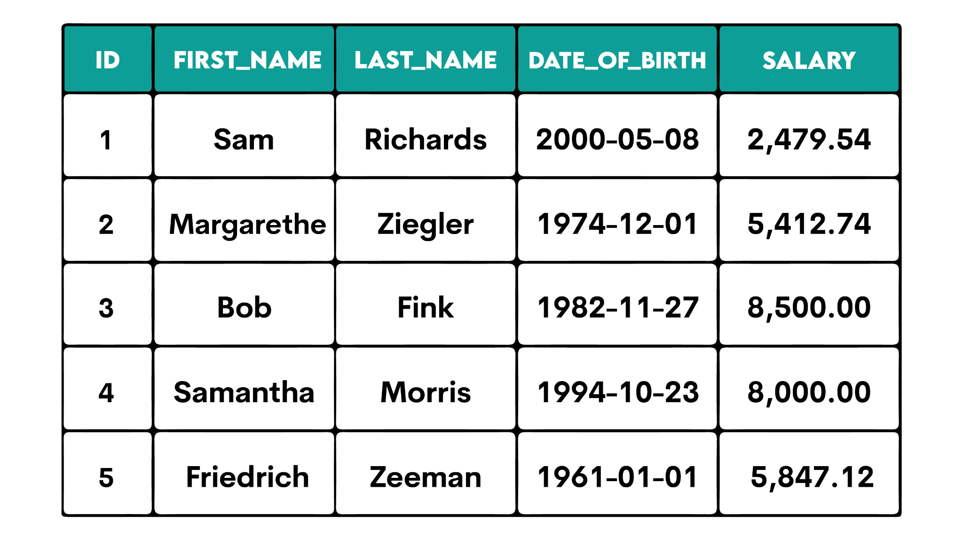
- Each row in a table is called a record. Each record has properties which correspond to the different columns in the table.
    - Each row is one individual datapoint. In this table, each row represents one person and their respective data.
- Think row = record and column = property.

- Now here’s an example of an ERD (Entity Relationship Diagram), which provides a total overview of the tables in a DB and the relationships between them. (A lot of DB editing software like DBeaver will generate these for you!)
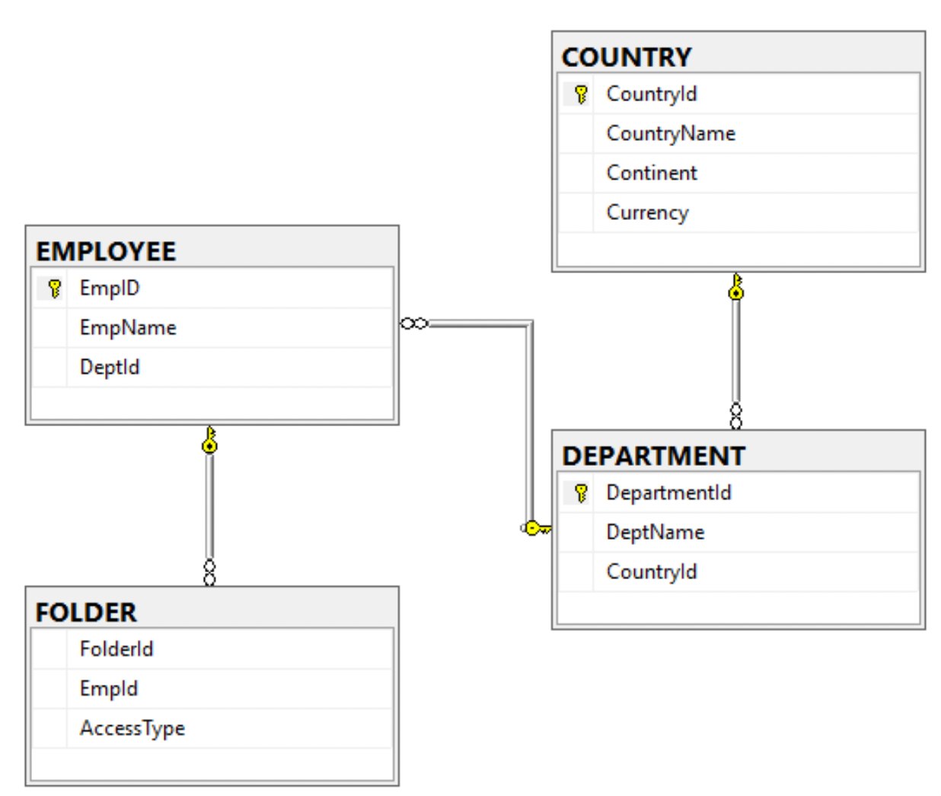

- SQL has a TON of datatypes, which you can skim through here. But mostly we just use text, int, boolean, and other specific stuff like date_time.
  - https://dev.mysql.com/doc/refman/9.7/en/data-types.html
  - Of note is CHAR and VARCHAR which let you make more restrictive string
    - CHAR is used for strings of exactly X characters. Good for things like state abbreviations
      - state CHAR(2)
    - VARCHAR is a string UP TO X characters. Good for strings of VARying lengths.
      - username VARCHAR(12)

Sublanguages of SQL
- The sublanguages of SQL are groups of SQL commands that are grouped together based on what they do.
  - E.g. DDL commands are related to defining tables, while DML commands manipulate the data within the tables.

- DDL (Data Definition Language) - SQL commands related to building the structure of your database. They DEFINE the database architecture.
  - Create - Most commonly defines tables and their column
    - Also can create schemas and views
  - Alter - Changes the columns of a table, or adds columns/constraints
  - Truncate - Removes all data from a table (Some argue this is DML)
  - Drop - Deletes structures like tables entirely (will also drop the data)

- DML (Data Manipulation Language) - Commands for actually using (manipulating) data in our tables. These are the commands with parallels to the CRUD operations.
  - Select - Retrieve data from a table for us to read or use in whatever application called for it. (Some argue this is DQL, not DML)
  - Insert - Add rows (records) to your table
  - Update - Modify the rows in our table
  - Delete - Deletes rows in a table (can be dangerous. If other rows depend on the row you’re deleting, your database will not be happy)

- There is also DQL (Data Query Language), which is just select. Some argue that select belongs to its own subclass (DQL), while others argue that it’s just part of DML. Feel free to argue amongst yourselves, just know that this discourse exists.
  - The argument for DQL, which I agree with, is that select does not actually manipulate data, so it can’t be considered part of DML. You query the DB with select, you don’t manipulate it. Therefore DQL exists.

- TCL (Transaction Control Language) - A transaction is a group of strongly related SQL queries/commands that run as a single unit following certain properties (ACID properties - read below). The statements must all complete successfully, or none of them get to complete.
  - start - Starts a transaction
  - commit - Complete a transaction, save the queries to the database
  - rollback - To revert back to the savepoint in case of errors (happens under the hood if the transaction fails)
  - savepoint - To set up a temporary save while the transaction is running

- DCL (Data Control Language) - For managing access to the database and permissions to structures in the database (like tables, schemas). This is mostly used by database admins. (Not us Python Data Analyzers)
  - Grant - gives privileges to users
  - Revoke - removes privileges
  - Create user - makes new user accounts in the database
  - There are also commands for altering/dropping users

Constraints (You will need Primary Keys and Foreign Keys to create relationships between tables!)
- Constraints are a limit on the data that can go into a table (hence the name constraint). They specify rules for a column in your table.

- Some common constraints:
  - Not Null -> This column can’t be null
  - Unique -> Cells in this column can’t have data identical to one another
  - Default -> Assigns a default value if one is not provided
  - Check -> Run an expression against some value to determine if it’s allowed in or not
  - Primary Key -> Uniquely identifies a row in a table (combination of not null and unique constraints)
    - There are 50 John Does in the Users table… How can we differentiate between them? Primary keys.
  - Foreign Key -> Creates relationships between tables. Foreign keys are always primary keys of another table
    - Specify a column as a foreign key with the “references” keyword
    - A foreign key will typically be called something like student_id_fk. So using the students example: Imagine every student has a backpack. The backpacks table will likely have a student_id_fk column that references the student_id column in the students table
      - THIS is how we establish relationships between tables.

The “Where” Clause
- The Where clause is used to filter the results of a select statement
  - Amongst other things… it also helps us specify when updating or deleting
- select * from table_name WHERE (column_name) (expression);
  - Selecting all data where a certain condition is met
- There are many operators we can use to filter results
  - = != > <
  - + - / *
  - Not, and, or
  - Between
  - In, not in
  - Like %
    - We call % “wildcard” in SQL, because that’s exactly how it works. It can be anything. Useful for searching stuff like names starting with N.

Order By
- The order by clause lets us specify the order of the records returned following a select statement. “Order by” goes in ascending order by default, and you must specify “desc” if you want descending order

- Select * from table_name order by column_name
  - For instance, if the column was an int field, you’d get the data in ascending numeric order. Text based fields are ordered alphabetically.

SQL Functions
- SQL has several functions that let us perform more complex calculations on data
- Scalar functions
  - Take in a single value and return a single value based on some calculation.
  - Upper, lower, round, now (returns the current time)
- Aggregate functions
  - Take in a group of values and return a single value calculated from the set
  - Avg, min, max, sum, count (count’s the number of returned records)

- You can also create custom user defined functions if there is some specific functionality you would like to save for ease of use. We won’t do this :)
Hypothetical function that takes in an int and returns it in dollar format:
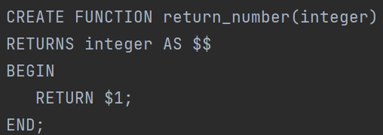
- Then you would call return_number(some_number) to get your dollar format

Group By and Having

- The “group by” statement and “having” clause follow aggregate functions to further transform data from a query.
- Group By combines rows together based on equivalent values in the column. And yes, we saw something similar with Pandas DataFrames
- Having behaves like a where clause, but it’s used after aggregate functions
  - Specifically, it filters the rows affected by the Group By clause
  - “Having” operates on aggregated data. “Where” operates on the entire dataset.
    - In other words, “Where” works only with the “Select”, so it won’t work on result sets created via aggregate functions. That’s what “having” is for.
Example stolen from a W3 article that’s a good read: https://www.w3schools.com/sql/sql_having.asp
Here’s the syntax:
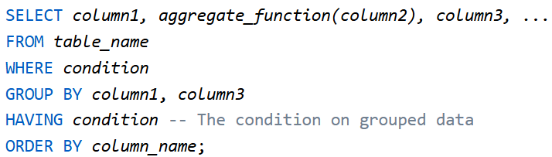

And here’s a more realistic example: This query returns the number of customers from each country, sorted from highest to lowest number, and only includes countries with more than 5 customers.
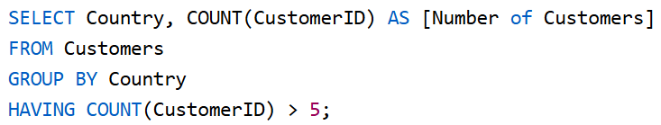
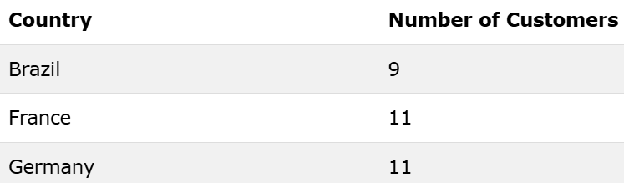

Referential Integrity
- As stated above, Foreign Keys allow tables to reference each other. For this relationship to work, SQL applies some special rules to the foreign key constraint to maintain the integrity of your references.
  - So “referential integrity” just refers to the rules that SQL imposes on Foreign Keys. They maintain the integrity of your PK/FK references.

- Rule 1: Our column in the FK table can only refer to a value/column that exists in the PK table.
  - Otherwise you’ll get the classic “foreign key constraint violated” error.
- Rule 2: You can’t always update or delete a value that is contained in the column in table B, since the FK table depends on the values in PK table.
  - SO if I reference data in a different table, the data can’t be changed or removed to break that reference.
    - So… how DO we update/delete records that have other records depending on it?
*NOTE: In SQLite, referential integrity is WAY less of a concern. We can break these rules no problem. But just consider how broken your DB can get if you don’t follow the rules.
- We can use cascade, when creating our tables which is a keyword that allows us to take an operation like update or delete and have it replicate itself on all referenced rows
  - If 4 rows in B reference a row in A, and I cascade delete the row in A, it will also delete the 4 rows in B.
    - In other words, the delete will CASCADE to any related records

- We typically specify cascade as part of the foreign key constraint (on update/delete cascade)
  - column_name int REFERENCES table_name (table_PK) ON UPDATE CASCADE
    - “CASCADE” this change to dependent records.

- We can cascade on DROP
  - e.g. DROP TABLE table_name CASCADE

Multiplicity (AKA Cardinality)
- “Multiplicity refers to the different ways we can build/define a relationship between tables in your database” -Good starting QC line
  - We have already seen One-To-Many relationship in the FK demo

- With Multiplicity, we are always talking about two tables of data and how they’re related
  - E.g. Every pet has one owner, one owner can have many (or no) pets.
- There are 3 types of multiplicity relationships in SQL:

One to One

- One row in table A is directly related to one row in table B. One and only one record in a table is associated with one and only one record in another table. Think user and passport, or product and product details (if you truly need to separate those…)
  - How to Implement:
    - I like to implement 1-1 by having a foreign key with the UNIQUE constraint, so that a maximum of one record from table A can be related to a record in table B.
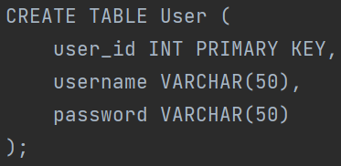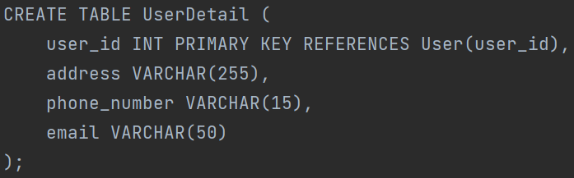
I don’t see 1-1 being used TOO often - it’s a very specific relationship that doesn’t manifest too often in the real world. The most I’ve seen were in College assignments…

One to Many (if someone says Many to One, it’s the same thing)

- One row in Table A can have many rows in table B that are associated with it.
- We always track this relationship on the MANY side. Recall how we had the foreign key on the employees table in our DML demo.
  - One role can have many employees. We put the foreign key (REFERENCES keyword) in the employees table.
- How to Implement:
  - The Many table will have a single column FK to the related PK in the One table. Just like we saw in the pets table.
  - Ex: One team has many athletes -> athlete would have a foreign key to the team’s primary key, which would be something like team_id.

Many to Many

- Many rows in table A can be associated with many rows in table B, and vice versa.
- In this case, we need to create a third table because SQL can’t handle this otherwise.
  - How to Implement:
    - This third table (join table, many to many table, junctions, associative entity) has two different Many-To-One relationships. One with table A, and one with Table B. It sits between them.
    - Let’s say the join table is table C. Table A and Table B will both have a one-to-many relationship with Table C. By doing this, Table A and Table B get a many-to-many relationship. Table C is created PURELY to track this relationship.
      - Consider students and classrooms. A student can belong to many classes, and a class can have many students. We would need to make a third table called something like “enrollments” and it would have foreign keys to the primary keys of classes and students. This is how we can track students and their classes.

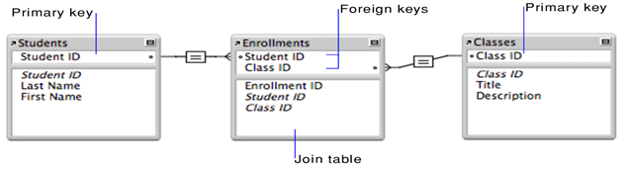
https://blog.devart.com/types-of-relationships-in-sql-server-database.html
^ Hopefully helpful article, if the diagrams confuse you don’t worry, we won’t have to make them. It’s in SQL Server, but the concepts are the same

Normalization
- In short, normalization is a set of rules that we follow in order to write good (sane) database tables. Normalization is a strict process of multiple levels that focuses on reducing data redundancy and improving data integrity.
  - Data Redundancy is when the same piece of data exists in multiple places. This can cause your data to become inconsistent.
  - Data Integrity is just the overall accuracy, completeness, and consistency of data.
    - If your data is redundant, there’s a chance of low integrity (in SQL specifically, NoSQL disciplines may have different priorities).

- The set of rules normalization provides helps us build sane databases.
  - We have from 0 - 6 Normal Form, we’ll just learn up to 3rd NF.
  - Most businesses stop at around 3NF, nowadays many businesses are actually stopping at what they’re calling “2.5” NF.

- 0th Normal Form
  - We have tables full of data.
  - No other rules
  - A lot of NoSQL DBs can look like this without issue! Not so much with SQL DBs though, since explicitly defined relationships are integral.

- 1st Normal Form
  - Tables must have a primary key (our unique identifier)
    - Can be a composite key, which is a primary key composed of multiple columns (this is usually bad unless you’re in a join table).
  - Columns must be atomic
    - Columns must hold exactly one value no more, no less
    - In general terms, “atomic” means it’s as small as it can get.
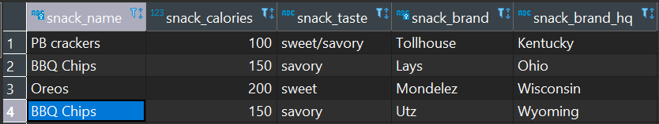

- 2nd Normal Form
  - Be in 1NF
  - Remove Partial Dependencies. (Have a single column primary key)
    - A partial dependency is when a piece of data depends on only one part of the primary key (can happen we have composite keys)
      - If you have a single column as the primary key, there’s no way to have a partial dependency. We’ll almost always see this as a serial id primary key.
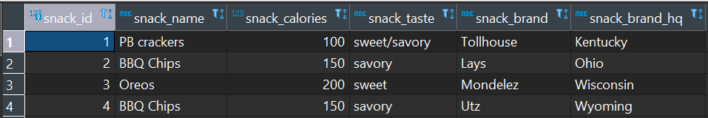
- 3rd Normal Form
  - Be in 2NF
  - Remove Transitive Dependencies
    - A transitive dependency is when a column depends on another column besides its primary key
      - Changing one column may change a dependent column. This usually only happens if your tables are bulky and not split into different tables.
    - We remove transitive dependencies by separating data out into a new table wherever possible.
      - Making different tables in the database (when necessary) is usually how we’ll achieve 3rd normal form.
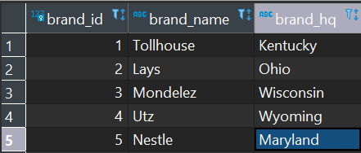
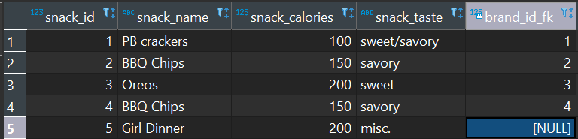
Brand data and snack data are now separate! With a FK linking the two tables.

Joins

- “A join is used in a query to combine rows from two or more tables, based on a related column between the tables (typically your primary/foreign keys).”
- This is how we achieve multi-table queries!
  - We’ll typically join on PK/FK relationships to ensure matches, but you can do joins on any column.

- Types of Joins we’ll see:
  - Inner joins -> Return rows with matching values in both tables
  - Left outer joins -> Return every row in the left table, and matching rows in the right table
  - Right outer joins -> Return every row in the right table, and matching rows in the left table
  - Full outer joins -> Returns all rows from each table

- “Left and Right” are dependent on the tables positions relative to the “join” keyword
    - The only thing that matters when determining left vs right is the positioning around the join syntax!
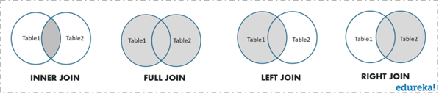

- Other Joins on the curriculum:

    - Cross Joins return the cartesian product of the joined tables
      - The cartesian product is all possible ordered pairs between the tables.
        - In other words, you would use this to create a combination of all rows from each table.

    - Equi Joins combine tables based on the equality between the values in the column of one table with the values in the column of another table. It uses the "equal to" operator (=) in the WHERE clause to match records.
      - This is essentially just an inner join but it’s listed as its own thing in the curriculum… lol
      - BIG PICTURE: Equi Joins are just any join that uses “=”
- Theta Joins combine tables based on some comparison operator (=, !=, >, <, etc.). So a theta join that uses = is just an equi join, which is just an inner join. That’s fun.
  - BIG PICTURE: Theta Joins are just any join that uses comparison operators.
https://www.postgresqltutorial.com/postgresql-joins/ - if you need some extra content. It’s for postgresql but that’s not an issue in this case.

Transactions (and the ACID properties)
- A transaction is a group of one or more SQL statements that execute together, under a certain set of properties - ACID Properties
  - Read up on TCL at the top of this document (It’s one of the Sublanguages)

- Transactions are important for data integrity, or when you need a group of statements to either succeed or fail together - no in-between.
- A - Atomicity (atomic)
  - The entire transaction happens in one go, or it doesn’t happen at all.
  - Every SQL statement in the transaction must complete successfully, or we undo everything the previous statement did.
    - If 99 statements succeed, and the last one fails, all 99 get rolled back!
  - Atomic (Atomus - The transaction can’t be broken down further. We can’t have a smaller piece of the total transaction succeed alone)
- C - Consistency (consistent)
  - The database has constraints… (PK/FK, Unique, Not Null, etc.)
  - While transactions are executing, we never enter a state where constraints are disregarded.
    - Can’t deviate from the constraints of your DDL while transactions are executing. In other words, transactions are not above the law.
- I - Isolation (isolated)
  - In practice, many transactions can be running concurrently (at the same time).
  - Each individual transaction runs as if it was the only transaction running. This avoids collision of the database
  - Transactions can’t interfere with each other! The database implements this for us.
    - SQL has different transaction isolation levels that we can change - the more isolated transactions are, the less they can affect each other, and the more reliable they become
    - BUT the more isolated we make a transaction, the slower our database will function.
    - If you want to look into it, the levels are in the curriculum, and the default level is “Read Committed”.
- D - Durability (durable)
  - If the transaction completes, all data is saved to the database's physical medium.
  - The data won’t be lost after a transaction completes. Saved forever!

*Just wanted to show a transaction, since we won’t see/use any yet.
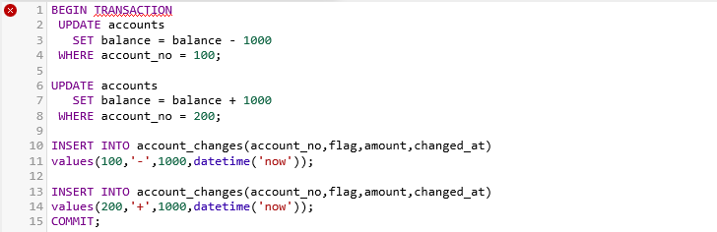
*Note the BEGIN and COMMIT commands - part of TCL

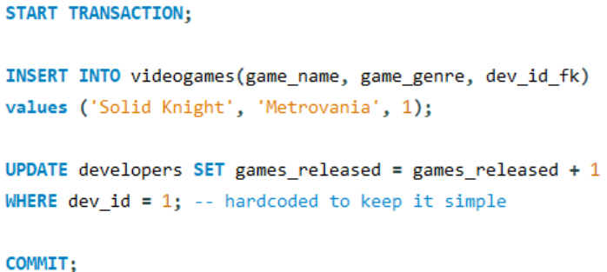

What is a Schema?

- A set of related tables grouped together under a single name. If your Database gets so complicated that you need to organize related tables into their own subsections, you’ll have to create multiple schemas.
  - More simple projects simply operate under a single schema. And yes, tables in different schemas can still talk to each other, by referencing tables by their schema name first. (select * from schema1.users)

Look at this. What a mess huh? Multiple schemas are desperately needed here.
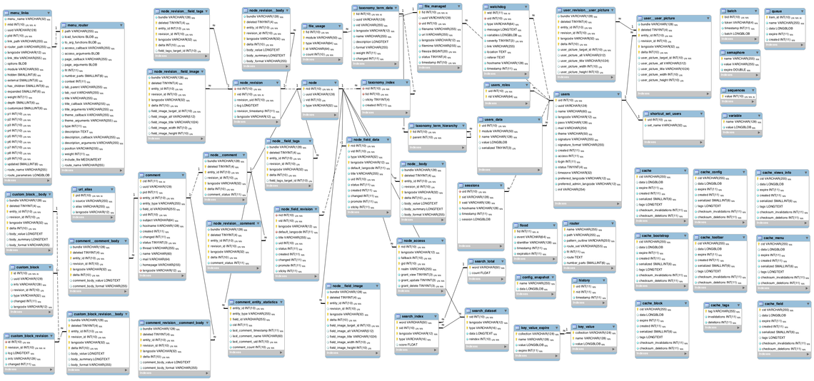

Subqueries

- A subquery is a SQL query nested within a larger query (or multiple queries). We use subqueries essentially as another way to filter data to be retrieved from a query.
  - You can think of it like querying a result set, instead of all the available data.

We want to find products with higher prices than the average price of all products.
- Don’t do this!
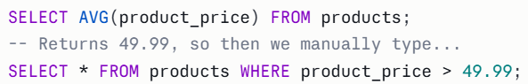

- Use a subquery instead!

SELF STUDY TOPICS (NOT on the curriculum this week)------

Views
- A view is a database object that stores a query. They’re just virtual tables returned to us based on the resultset of our SQL queries.
  - We can create our own views, which will act as a stored query for easier access.
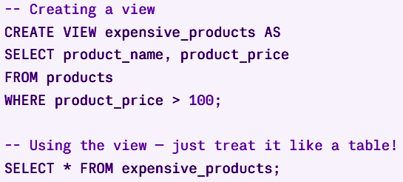

Indexes
- An index is a copy of selected columns of data from a table, designed to speed up data retrieval from a table.
  - An index in a database acts pretty much like an index in a book. You don’t have to scour the entire database/table to find a certain set of information. It’s indexed for you, so you can flip right to where the data is located.

There are two types of Indexes -

- Clustered Indexes define the order in which data is physically stored in a table. It’ll actually follow the order that the records were inserted in.
  - The primary key constraint automatically creates a clustered index on that particular column
  - We can only have one clustered index per table, since the records can be stored in only one order.
- Non-Clustered Indexes are stored in a different location than the database tables. This allows for multiple non-clustered indexes per table.
  - Non-Clustered indexes don’t sort the data inside the table.
  - These are more like a textbook - data is stored in one place and the index is stored elsewhere. (In a structure called the heap).

When creating an index, you specify one or more columns to create the index on
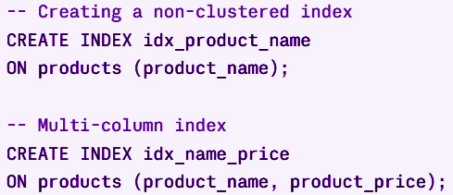

- Pros:
  - Speeds up data selection (since the data is indexed, the DB can jump directly to where the data is stored and retrieve it)
- Cons:
  - Takes up memory to create an index
  - Slows down the other CRUD operations (insert, update, delete)
    - Since the info is indexed, the data has to be changed in more than one place, slowing down the process.

Stored Procedures

- A stored procedure is a named collection of SQL statements stored and executed on a database. It can be called and executed multiple times by different applications or users.
  - What’s the point?
    - Stored procedures are typically used to group frequently executed or complex database operations. They provide several benefits, including improved performance (speed), reusability, security, and abstraction of database operations.
    - Would you rather type a complex 15-line group of queries and DML multiple times a day? Or store it once and call it at will?

Creating a Stored Procedure (note the price_threshold argument!) -
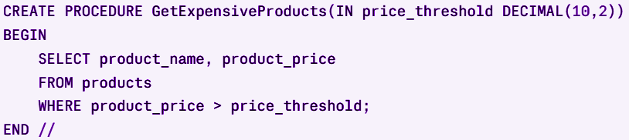
Then call it as needed!
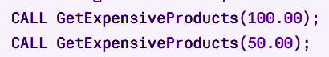

Triggers
- A Trigger is a type of Stored Procedure that automatically executes in response to a specific event on a table.
  - This “event” can be pretty much any DML command. (Insert, update, or delete).
    - You don't call a trigger manually, it just fires (aka triggers) on its own when the specified event happens.
"Whenever a new order is inserted into the orders table, automatically update the inventory table."
“Whenever the balance is updated from an account in the accounts table, automatically insert a new record in the transactions table”
- Common use cases:
  - Audit logging
    - Automatically record who changed what data and when
  - Enforcing business rules
    - Prevent an order from being placed if stock is 0
  - Keeping data in sync
    - Automatically update a summary table when record details change
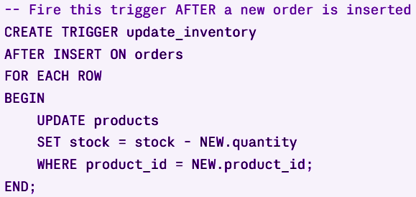

Triggers can be cool, and they feel fancy to use. Just make sure to use them deliberately and sparingly. It sounds like a nightmare to keep 50 triggers in mind as you use and change a database. As requirements change, triggers can start to do unintended things when left unchecked. In a database, that’s potentially disastrous.

Sequences
- A Sequence is a database object that generates a series of unique numbers automatically.
  - It’s most commonly used to auto-generate primary key values so you never have to manually assign IDs to new records. This is what’s happening under the hood when we use the serial or auto-incrementing datatypes for our PKs.
    - Remember the long version of serial is “auto_increment primary key”
- We’ll never really have a reason to make a sequence. They’re one of those things that are baked into SQL’s default behavior, and the topic made its way into the curriculum. So there you go.

